Interview: Jon Finkel Part 1
Toby Wachter
Thursday, December 13, 2001
The birth of competitive Magic was marked by name players such as Mark Justice and Olle Rade, who first defined what it meant to be a "Magic celebrity". Later, Jon Finkel took that role, and defined it further as he established himself as the best Magic player on the planet, winning a Pro Tour, Nationals, Worlds, the Invitational, and finishing in contention many, many times. Recent years have seen Magic become less of a priority to Jon, and Kai Budde has seemingly emerged as the next major superstar.

So how does Finkel feel about his title as "Best Magic Player in the World" becoming tarnished? Does he even care? Professional Magic sees more players "turn pro" and dedicate their lives to the game every year, yet Jon has decided to stay in school. Why did he make this decision when so many other talented players have? I recently met up with Jon at Neutral Ground in New York City to discuss these topics, along with others such as how much he playtests for tournaments, why he doesn't usually play the Grand Prix circuit, why the money is more important than the glory, and the making of Shadowmage Infiltrator.
Sideboard: How old are you, and how far along are you in college?
Jon: 23 years old, and in my final year of college at Rutgers University.
Sideboard: Why did you stick with college? Why not just go pro and drop school? A lot of players have decided to do that over the past few years.
Jon: Football players drop school to go pro. Basketball players drop school to go pro. They're not paying me a million dollars a year to play Magic, so I'm going to get my education in while I'm young instead of being the old guy at the back of the classroom when I'm 28. I'm slower than usual as is because I'm a little bit older, but I like school. I enjoy it. I don't think there's any need for me to drop out.
Sideboard: What do you think about Magic players that don't have a job or don't go to school because they dropped out to dedicate their lives to the game?
Jon: I think it's anyone's decision to figure out what they want to do, but I think some of them might be making poor decisions. That might not necessarily be for me to say. Magic probably isn't something you're going to do for your entire life, and a lot of these people now are making a lot of money playing it for someone their age. Still, it's something that will come back to haunt them if they don't go to school, and aren't psychologically able to work for money since they're used to getting money relatively easily for free.
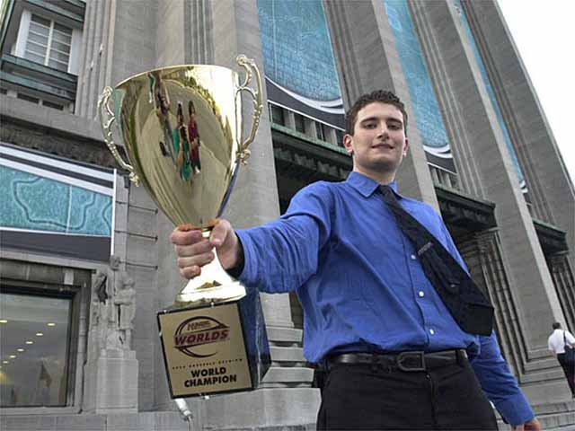
Sideboard: Do you think it proves something that you're going to school, and still doing well at Magic?
Jon: I don't know if it really proves anything. My strength in Magic has never been in my preparation. It's more because I have good friends and I'm good at drafting and have decent play skill... not necessarily good playtesting and preparation skill. So I don't know how much not going to school would help my Magic game.
Sideboard: I'm not sure if you want to get into this, but you actually flunked out of college the first time you went, right? Did Magic have anything to do with that?
Jon: It's possible to blame Magic, but I don't think that would be true. Basically I was never really a good student. I was a bright kid, but in high school I never would have gone if I didn't have to, and I didn't do homework. Then when I went to college, I didn't go to my exams because I didn't have to. It was dumb, but that's what happened.
Sideboard: So you don't think Magic had anything to do with it?
Jon: I think Magic slightly adversely affected my grades, maybe dropped my GPA by .3 or .4, but my grades in high school were never bad. I graduated in the A-/B+ range, so maybe it did. I don't really even know.
Sideboard: When you flunked out of college, that was during your first big run right?
Jon: I went to school in the '96-'97 school year, and then the year I took off because I failed out and had to was the '97-'98 year. So, 1998 Pro Tour-New York was actually at the very end of that run. The beginning of that was when I made my first Top 8 at Chicago.
Sideboard: So you had that whole year off, and that's when you had that big run?
Jon: Yeah, that was my first big run. That's when I won Player of the Year. I came in third at Chicago, won Pro Tour-New York, came in fourth at Nationals and then third at Worlds.
Sideboard: Is that because you were off from school and putting more time into Magic?
Jon: Yes and no. Yeah, I put a lot more time into Magic then, but I don't think it had as much to do with not going to school. I was playing a fair amount of Magic the year before that as well when I was in school... it was pretty much the same amount. So I don't think it's that cut and dry. Obviously it helps when you have more free time.
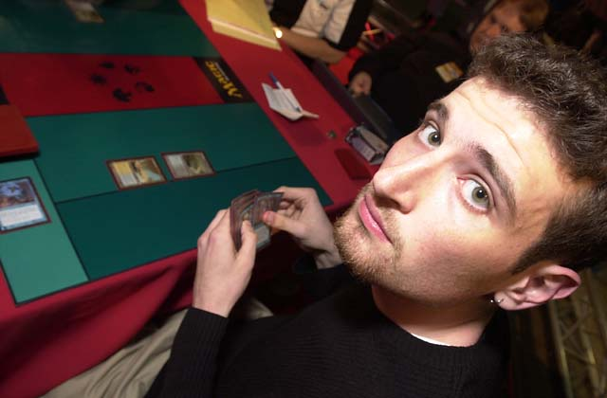
Sideboard: After you had that big year where you won a Pro Tour and came third at Worlds, why did you decide to go back to school?
Jon: Basically, if I didn't go back to school then, I didn't know when I was going to go back. Also, my days were kind of boring, you know? There was no structure to my life, and I'm not a huge structure person, but it's nice to have something you have to do. It keeps your life in focus.
Sideboard: What are you majoring in?
Jon: English.
Sideboard: And what's the plan after you graduate?
Jon: I really don't know at this point. At some point I might get a real job, I probably want to do some sort of trading on Wall Street. I think have the skills necessary to do it, and it's a good way to make money. I may go to grad school, I may not. I really don't know right now.
Sideboard: Have you given any thought to just playing pro for a few years after you graduate?
Jon: Well I'll keep playing Magic, but I don't think there needs to be this sharp delineation of black and white, playing pro or not playing pro. I'll play on the Pro Tour, I'll try however hard I feel like trying, and I don't know how much that will be changed by other things like whether or not I go to grad school. Actually, if I get a real job, then I'll have to stop, but that's not for another two or three years down the line.
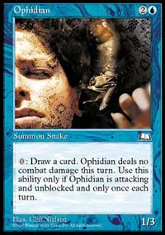
One of Jon's signature cards.
Sideboard: So do you think that once you get a real job you'll be done with Magic?
Jon: I don't know about done, but there are a lot of jobs where you can't really take that much time off, so it would definitely be a lesser part of my life. As long as I can keep supporting myself and living reasonably well by playing Magic and not doing other stuff I'd like to do that, but at some point I need to start building up for the future as well.
Sideboard: How much preparation have you been doing lately? I'm guessing that two or three years ago you put in more preparation time than you do now.
Jon: The last tournament I really put a lot of preparation time in for was 1998 Worlds. Last year I put in some for Nationals, some for Worlds. Lately, I just kind of play when I feel like it, but I don't really put in much preparation time.
Sideboard: Do you ever play for fun, or is Magic more of a job now?
Jon: Well I play for fun... I enjoy playing whatever, but I'd rather draft or play a relevant format. For example, I haven't played Standard when it wasn't a relevant format for as long as I can remember.
Sideboard: Do you ever get bored on a Friday night and decide "I'll go play Magic", or do you find yourself doing other things instead?
Jon: One of the major problems is that there's no real good Magic shop in my town, so it's a trip for me to go somewhere and play. All my Magic playing friends are in New York, and that's at least a hour and fifteen minutes each way, so it becomes less of "Oh, I'll just go and play", and more of something I'll plan to do.
Sideboard: How did you first find out about Magic?
Jon: I was living in England and there was a game store there and I was interested in games. (Starts to talk in a tone like he's told this story a thousand times) I walked in and saw some people playing Magic, I asked them what it was, they showed me how to play... yada, yada, yada...
Sideboard: Are you asked that question a lot?
Jon: (laughs) Yeah.

There's no such thing as a bad play, a good play, and a better play. There's the right play, and then there's the mistake.
Sideboard: Well, let's get the rest of the softball questions out of the way. What intrigued you about it?
Jon: I thought it was an interesting game. I come from a family of people who like to play games... my grandfather is very good at Bridge, and my father is good at Bridge although he didn't play as seriously. He's good at Chess and he plays computer games all the time. It's probably something genetic and partially environmental that makes me like games.
Sideboard: At what point did you realize you had a talent for the game?
Jon: I realized it relatively early on. It really became clear when I moved back to New Jersey and just realized that I was one of the best players at the store I played at, which at that point had some of the best players in the country.
Sideboard: That was David Bachmann, Feming Chan and Happy John (Chinnock)?
Jon: Yeah, pretty much. Feming not as much, but Bachmann and Happy John are probably the most well-known guys. All the people from Jersey who used to play, like Aaron Kline were good way back when.
Sideboard: So you learned from them?
Jon: Well, I think with anything you do like this, you're going to learn from anyone you play against. It wasn't like they just sat down and taught me, it's just that I was playing against other people who were good, and therefore I became better.
Sideboard: At what point did it go from something you played in a card store for fun to a job? Did you start putting more time into Magic once you realized you could make money off it? Jon: You know, there's an interesting psychological phenomenon... the more you get back out of something, the less likely you are to like it. They did a study where they have someone lie to someone else about something they did, and they'll say it was fun when it was really boring. In one group they gave the people a dollar to do it, and in the other group they gave the people twenty dollars. Later on they asked these people what they really thought about the task they were describing, and the people who were given one dollar actually rated the task as significantly more interesting than the people who were given twenty dollars. So, it's one of those things where I put in more effort, and I think enjoyed it more when I was getting less back out of it monetarily.
Sideboard: Interesting. When you were on the Junior Pro Tour, most people knew you as a good deckbuilder, and not so much as a great player. What do you think helped you to make that transition?
Jon: I wouldn't really say that it was a transition, it was just a matter of perspective and what people saw and thought. Back then, deckbuilding wasn't nearly as much of a science as it is now, and I had a little bit of a clue. I think I was always one of the better players, and people didn't realize that until later. As it turns out, I'm not really one of the best deckbuilders.
Sideboard: Do you think there's something you know that other players don't that gives you an advantage?
Jon: I have a unique perspective. Basically, I think there's no such thing as a bad play, a good play, and a better play. There's the right play, and then there's the mistake. Like people say "Well, I did this, it was a good play", but it really wasn't. It wasn't the most correct play. So therefore, it was a mistake even if it looks good or ends up winning the game.
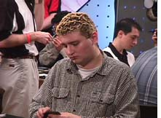
1999 Pro Tour-Los Angeles
Sideboard: Something that's interesting is that being in the Magic community now for five or six years, in the public eye so to speak, we've seen some image changes with you. You went from having the thick glasses to having dyed hair to where you are now. Do you think Magic had any effect on your image or personality over the years?
Jon: A question like that is kind of hard to answer because anything like that is a combination of a lot of factors that I couldn't even pinpoint. I would say that of the influences on my life, Magic was relatively small. Part of it probably had to do with me naturally and genetically, and it had to do with me going back to school and the people I hung out with there. Magic obviously had to have something to do with it, but I wouldn't say it was one of the largest parts.
Sideboard: At this point in your life, do you feel somewhat detached from the Magic community? Some people say things like "Jon Finkel doesn't hang out at the tournaments anymore". For example, Mike Turian still drives to PTQs even though he's qualified, just to hang out with the people there.
Jon: I'm a little detached. I still spend a lot of time hanging out with the Magic players who are my really good friends, but we don't necessarily do it at tournament sites. For example in New York, Dave Price, Eric Kesselman, Ben Murray, Brook North, Chris Pikula... these are people I'm really good friends with and I spend a lot of time with them, but not necessarily here (Neutral Ground) playing Magic. I don't really go to watch them play because in all honesty it's not that interesting to me to watch someone else play in a PTQ.
Sideboard: Even Grand Prix... I mean you didn't even go to Vegas. Why's that?
Jon: You know, I just really didn't want to fly out to Vegas. Basically, motivation is not a complicated thing. I just said, "Jon, do I want to go?" and the answer was no.
Sideboard: That's pretty simple. Is there any reason you don't go to Grand Prix in general even when they're close? Like for example, Boston last season.
Jon: It's just a time to schoolwork ratio type thing. I have to look at what time I'm giving up, what I expect to win, and how much fun it's going to be. I'm not a huge fan of traveling, and I travel a lot as is. So generally, I just try to avoid the Grand Prix. Sometimes I'll make an exception, but more often than not I'll just stay home.
Sideboard: So you basically only play in Pro Tours then, right?
Jon: Pretty much.
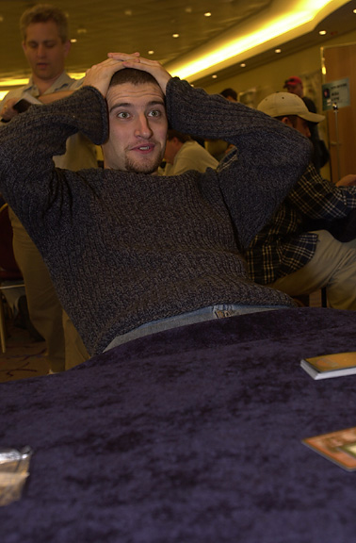
Sideboard: So is Magic more of a job than a hobby at this point?
Jon: It's an important part of my life. So many of my friends play Magic, and it's changed the way I perceive so many things. Is it more of a job? Yes, but maybe to the extent that basketball is a job to Allen Iverson. It's still something I enjoy doing, but it's definitely a job as well.
Sideboard: Some people seem to think that you only do well at a tournament if you're motivated. Is that true?
Jon: I don't think it's that true. I think that what people forget a lot is that there are lots of short-term variants in Magic. They tend to look at results as meaning more than they really do, although over the long haul, results are very relevant. Over a short period of time, especially in Magic where a short period can easily be something like two years, it's really relatively random what tournaments someone will end up doing well in. I mean motivation obviously helps create preparation. What happens a lot is that people look at it afterwards and will say "well, he did well here because he was motivated", and maybe that wasn't really the case. Maybe I was motivated for a different tournament, and they didn't know because I just didn't do well in it.
Sideboard: Have you ever been unmotivated for a tournament? If so, why?
Jon: I don't really know. I may have been unmotivated. There are tournaments where I really... especially Constructed tournaments where I didn't put in as much effort as I should have, just because it seemed like a lot of work, and who knows what I'm going to find out.
Sideboard: Well for example, the guys at Hampton Court Palace are notorious for testing hundreds and hundreds of games for every matchup. Do you feel like it's not worth it to compete with those guys, or maybe you feel that you don't need to do that because you're a better player than they are?
Jon: Basically they're going to do all that, and they'll come up with something a little better, but ten percent of the work can come up with ninety percent of the results, and I'm usually pretty happy with that.
Sideboard: Is playtesting unimportant?
Jon: No, not at all. I think it's very important and it's going to help a lot, but it's just a matter of how much time I'll put into it. If you put in a lot of time you'll definitely get a little edge, which is very relevant when you're playing for a lot of money. I just choose not to put in that time.
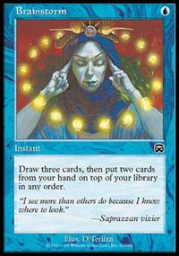
Sideboard: Well for example, for Worlds 2000 which you won, did you put in a lot of playtesting time for that?
Jon: I put in a fair amount of time for that. We played for a few weekends. We were pretty sure that Tinker was the best deck going in, and we played it against every other deck and it seemed to win. So I guess there I did, but it wasn't my idea to play it. I sat around and did a lot of playing and had some ideas on how to change the deck. Actually, the only thing I really did was add the Brainstorms, instead of whatever they were before. We put in some effort, but not an absolutely ridiculous amount... not to the same extent that they might do in England.
Part Two: Tomorrow, Jon contemplates who the best Magic player in history really is, explains what it's like to be a Magic "poster boy", why he doesn't feel the need to prove anything, and what it's like to have his own Magic card.

